Design Diagram Documentation:

1.Context Diagram:
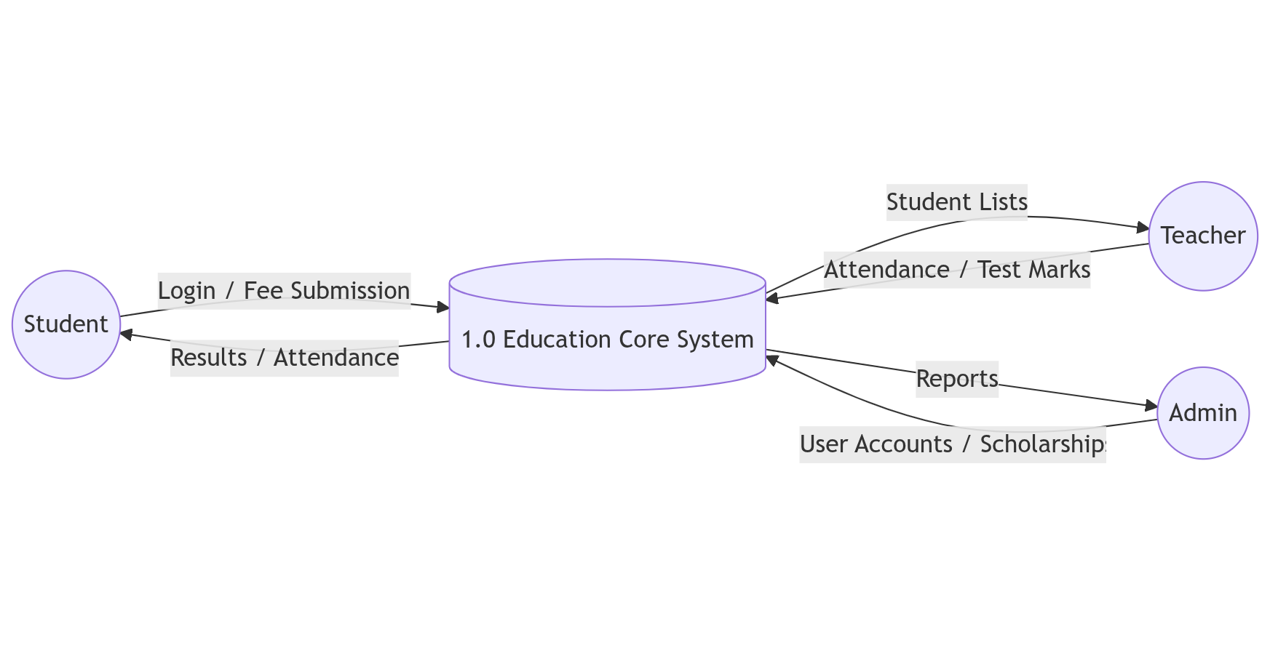

2.Data Flow Diagram:
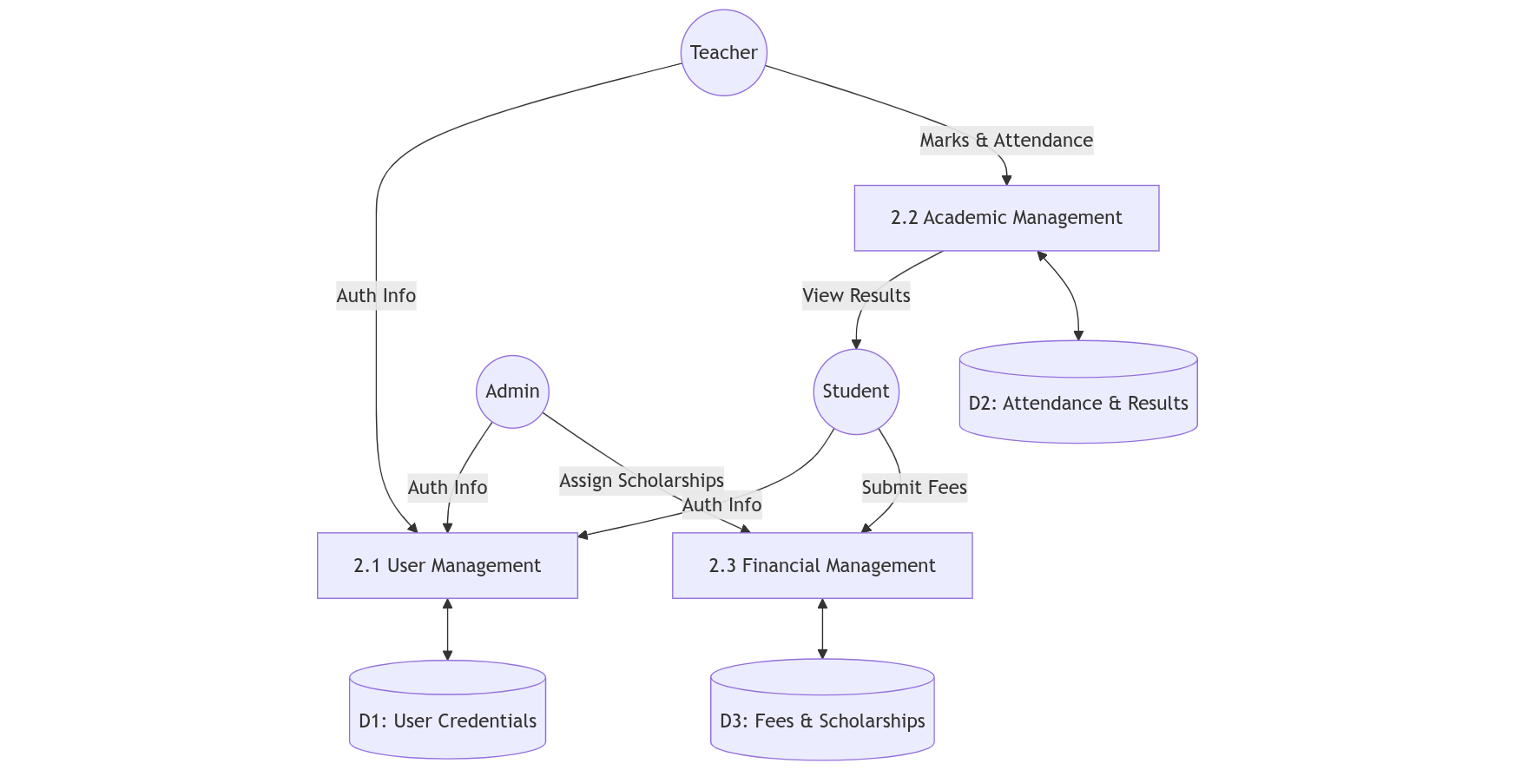

3.Entity Relationship Diagram:
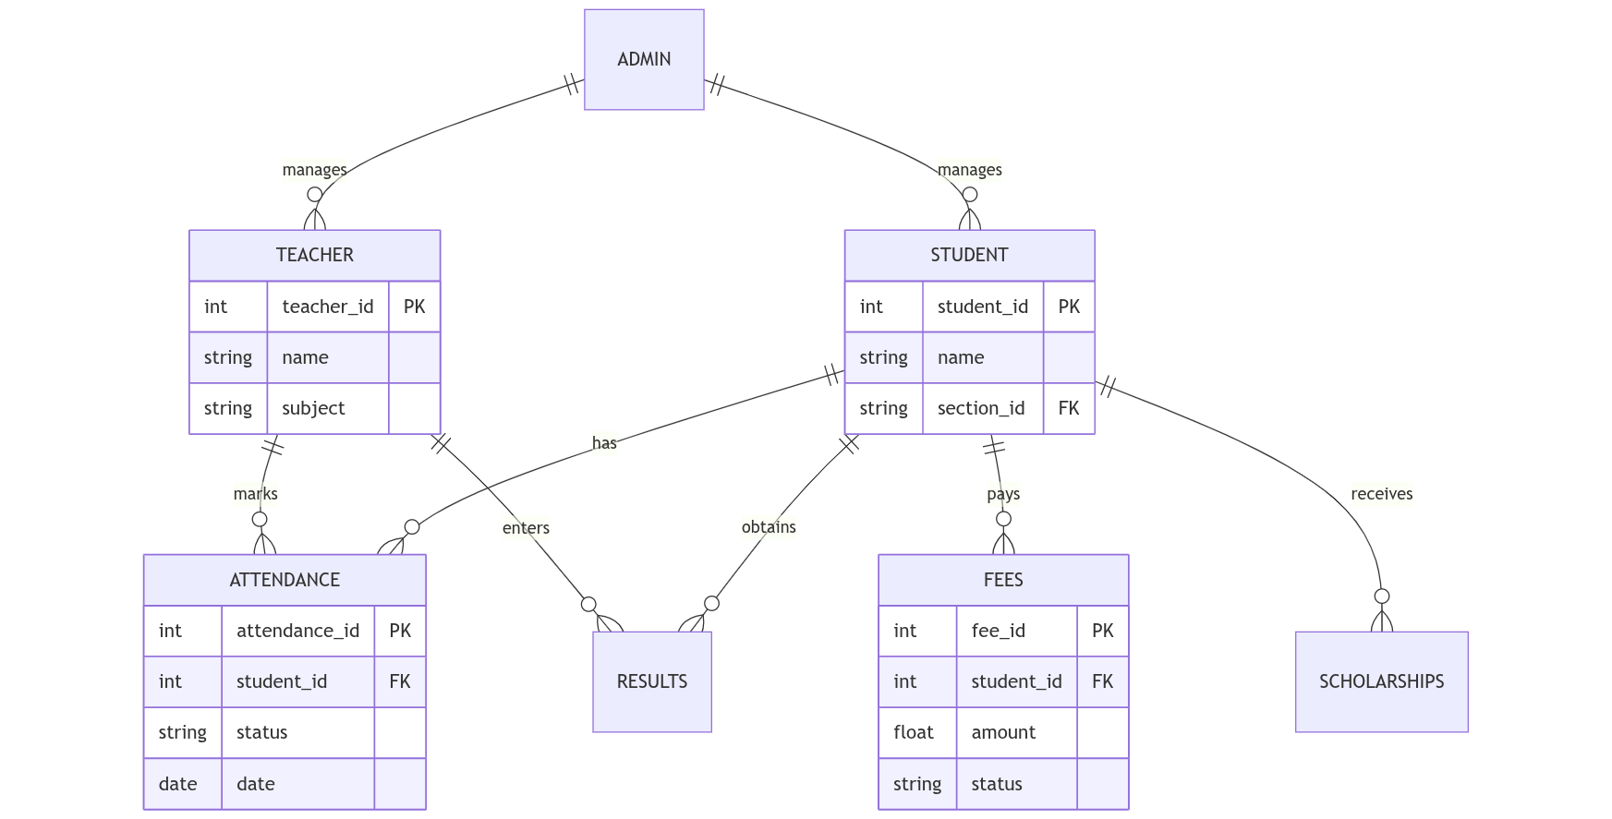

4.Activity Diagram:
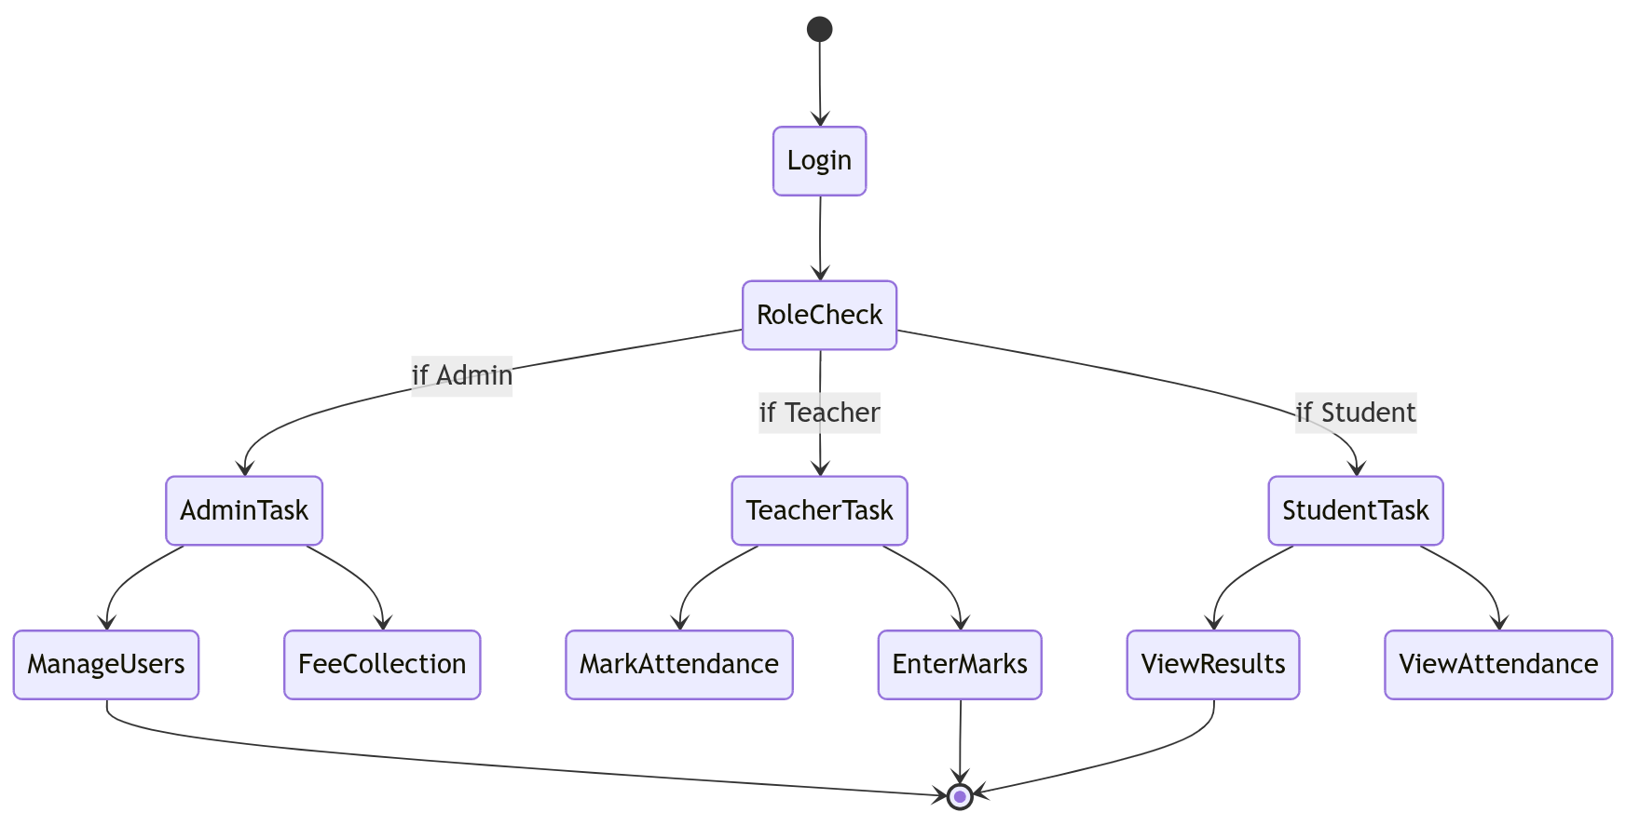

5.Architecture diagram:
